***LAB - 21***

Demo on Cloud Formation

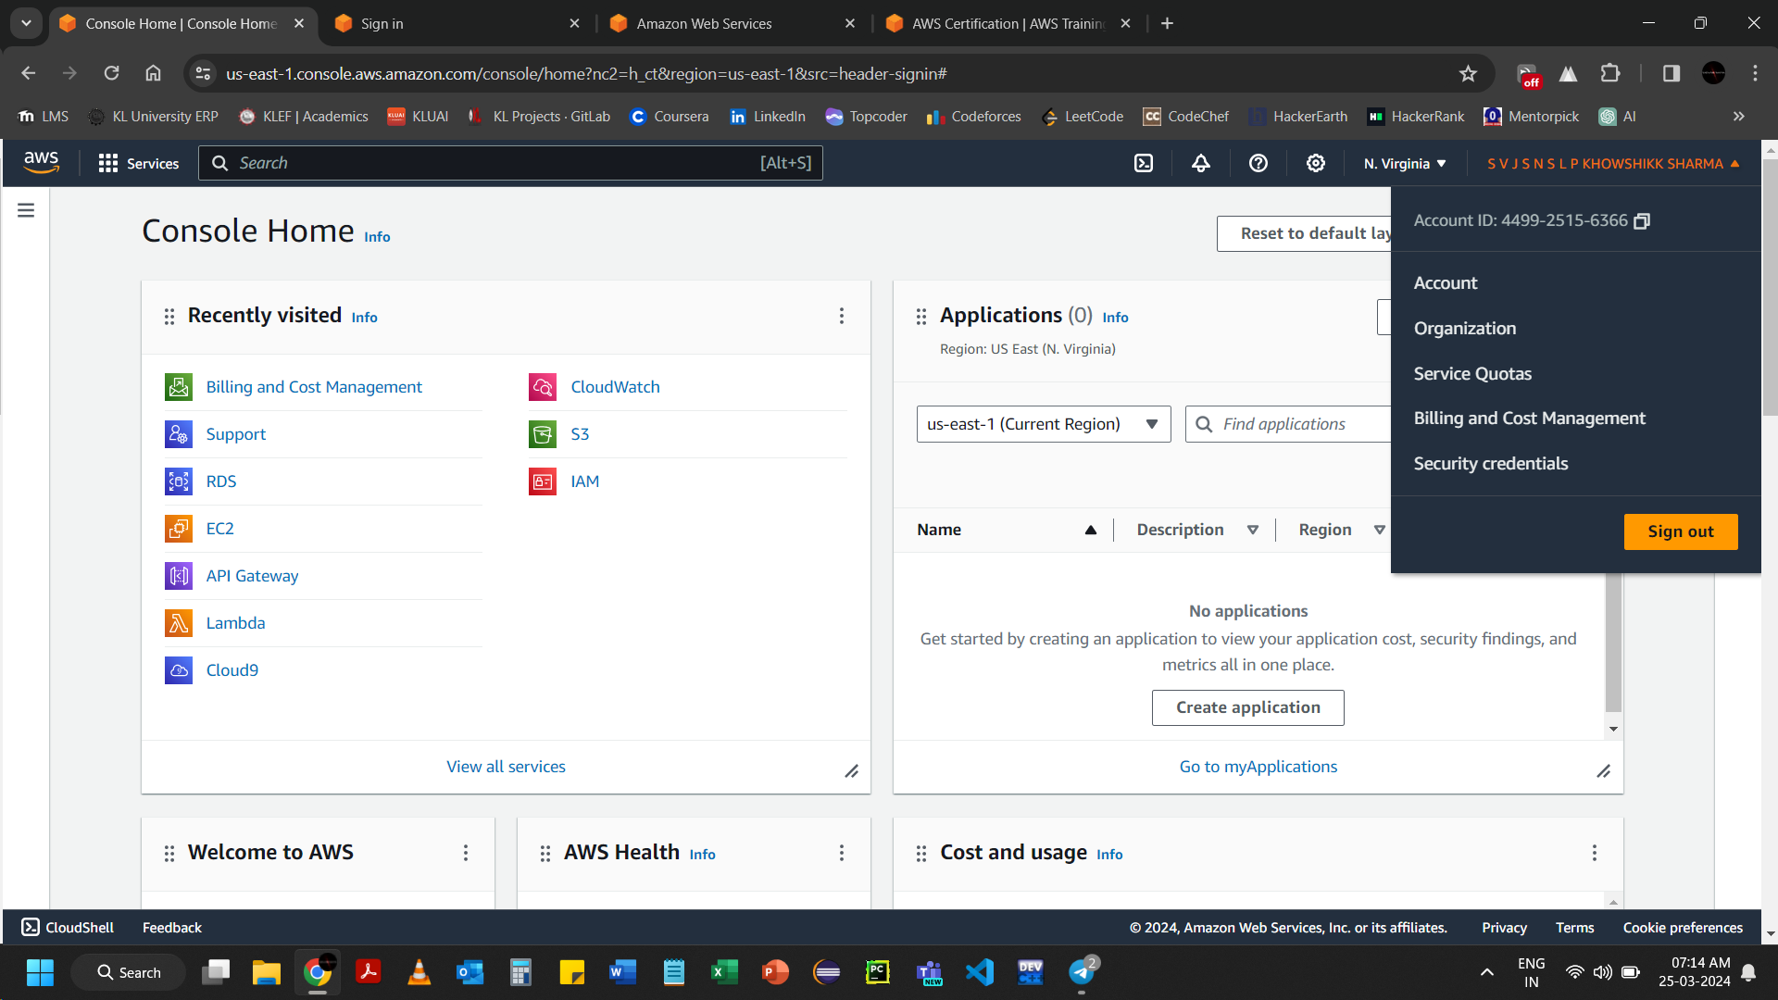

Search for CloudFormation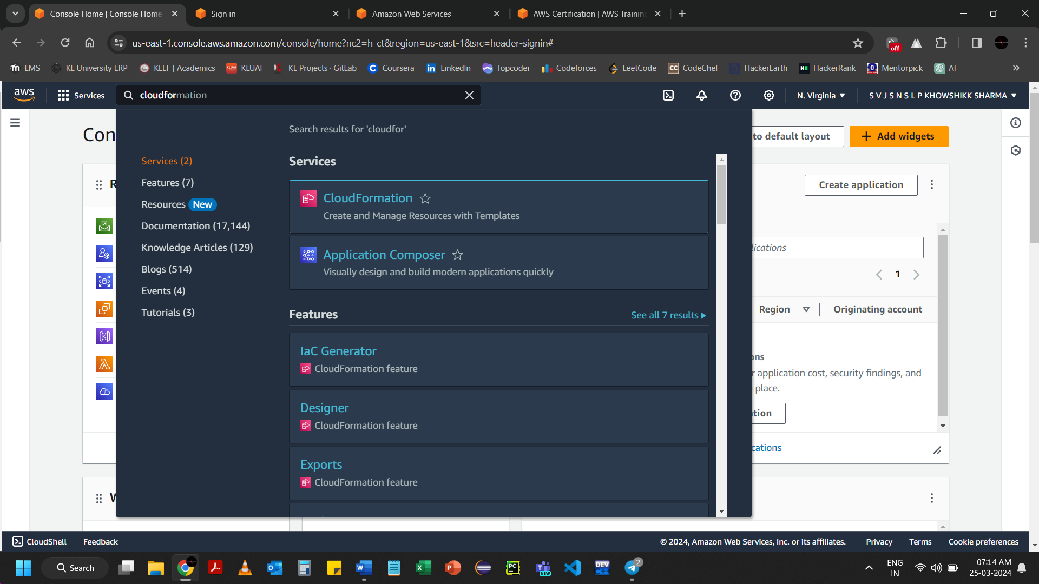

Create a file named ec2template.yaml

* Ec2

Resources:

MyInstance:

Type: AWS::EC2::Instance

Properties:

AvailabilityZone:

ImageId:

InstanceType:

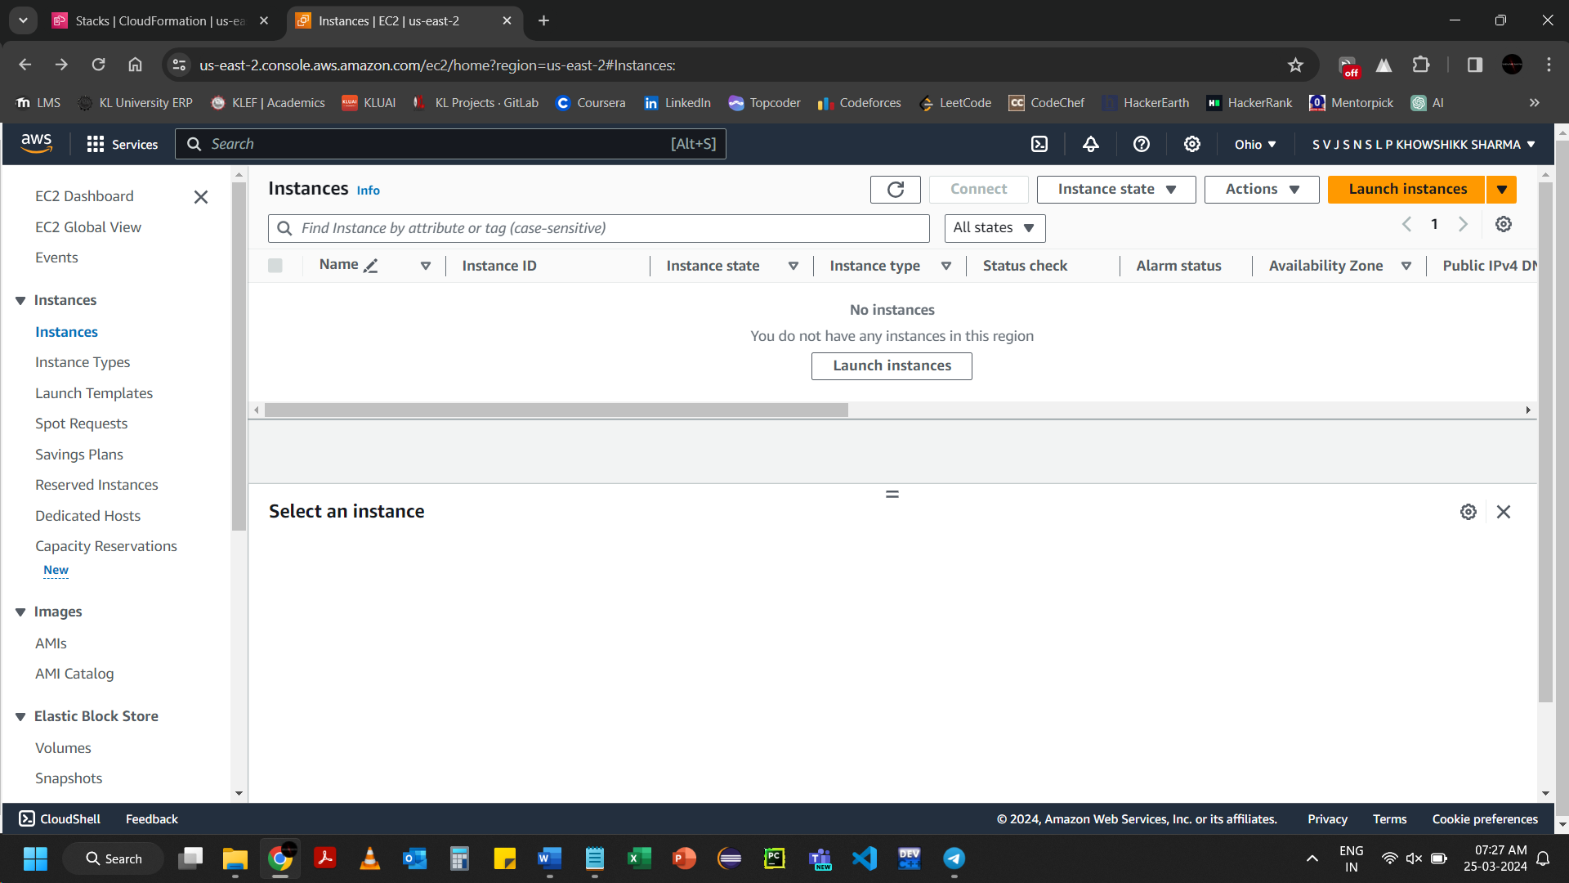Click on Launch instances

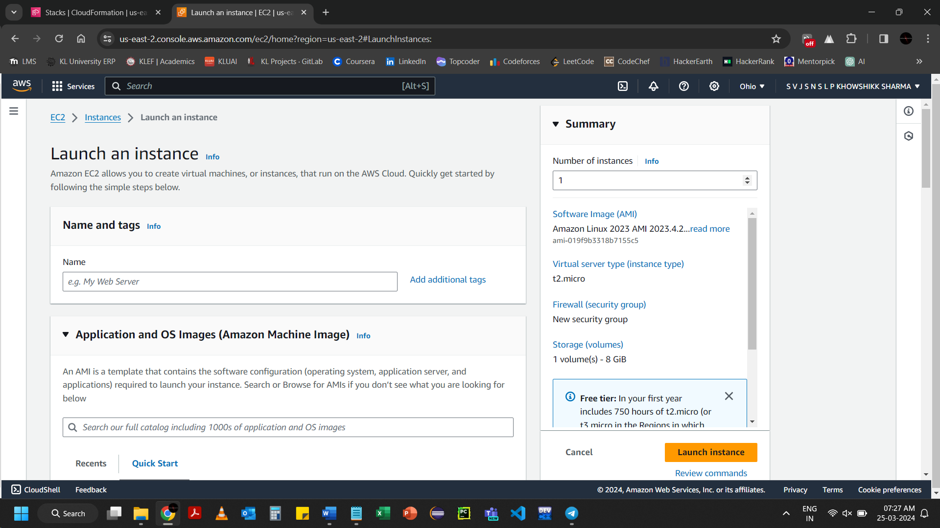

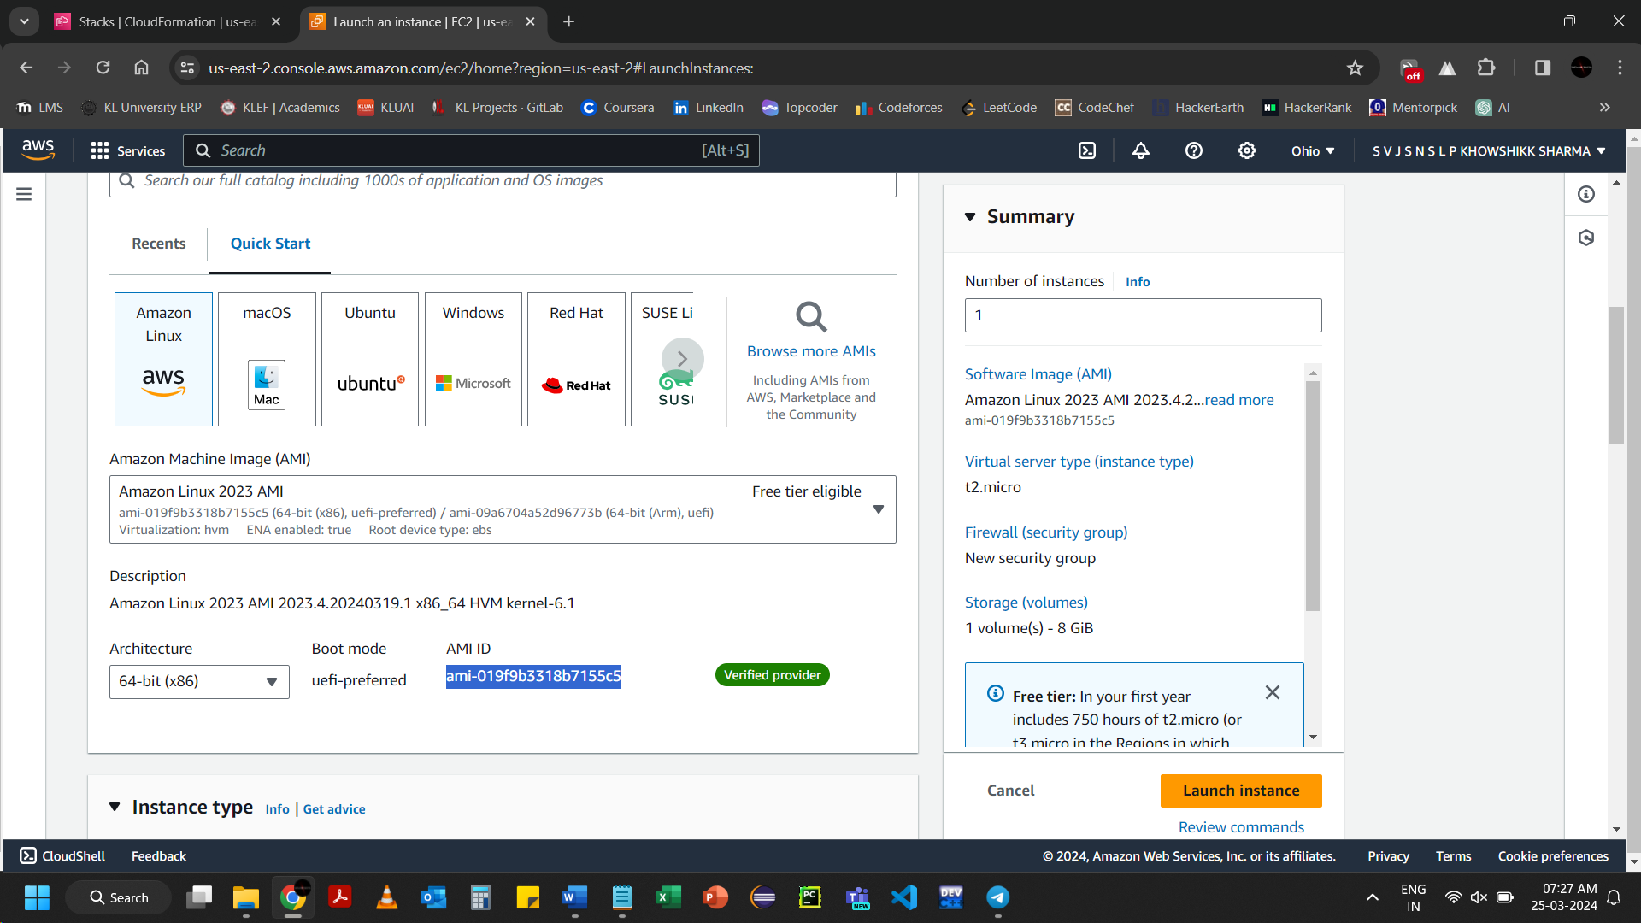Copy the AMI ID to paste in Amazon AMI ID in ec2tempalte.yaml

Resources:

MyInstance:

Type: AWS::EC2::Instance

Properties:

AvailabilityZone:us-east-2a

ImageId:ami-019f9b3318b7155c5

InstanceType:

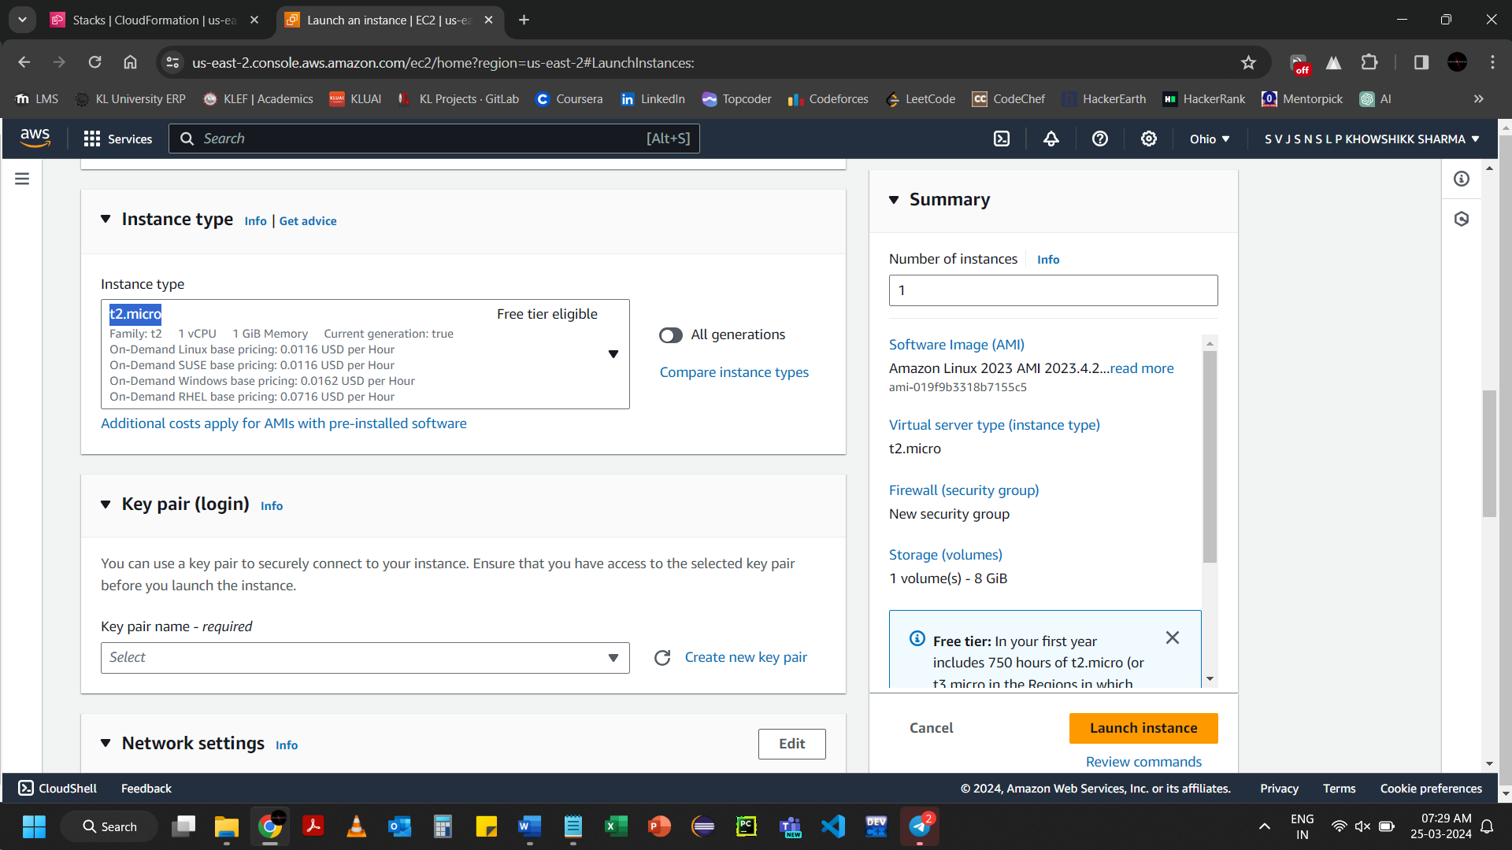

Copy the instance type to paste in InstanceType in ec2template.yaml

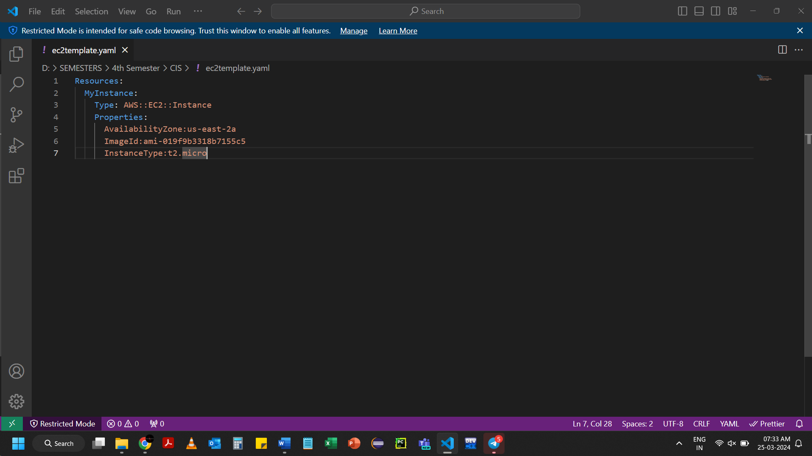

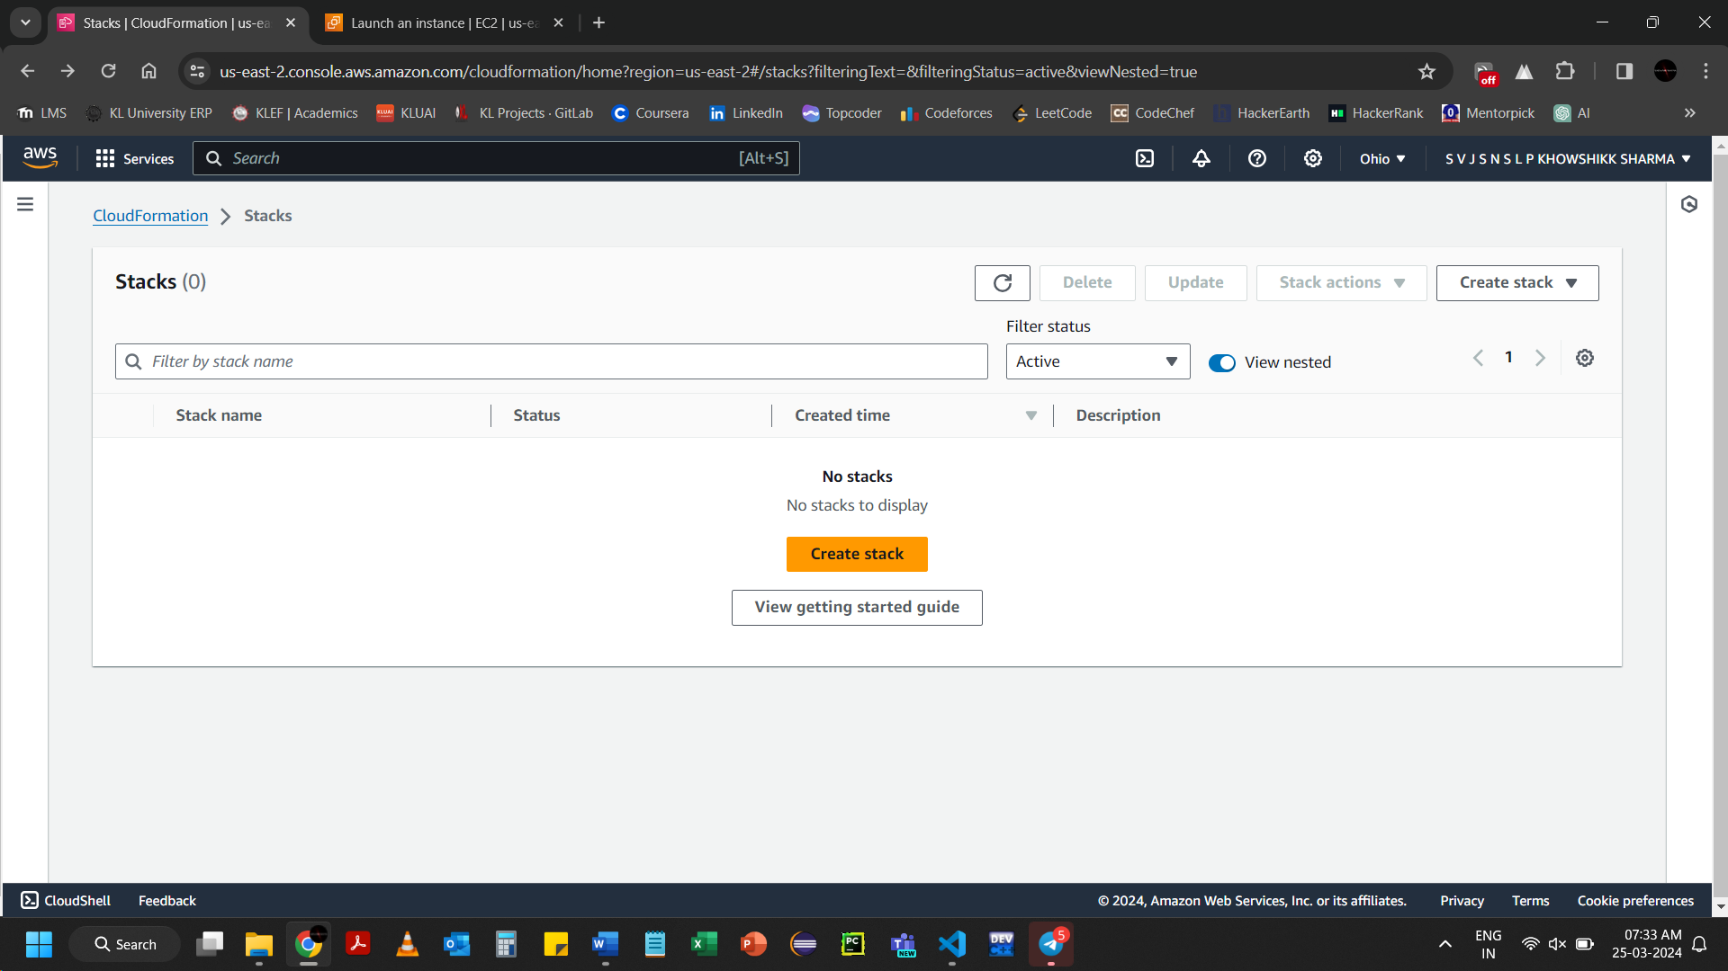Click on Create stack

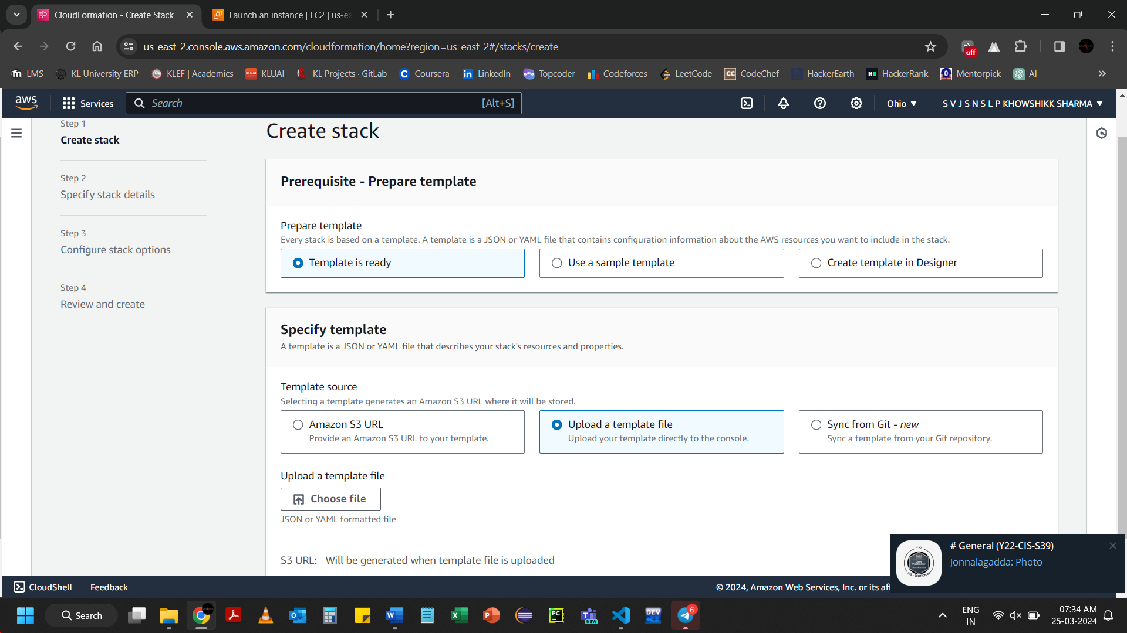

Resources:

  MyInstance:

    Type: AWS::EC2::Instance

    Properties:

      AvailabilityZone: us-east-2a

      ImageId: ami-019f9b3318b7155c5

      InstanceType: t2.micro

The last ec2template.yaml

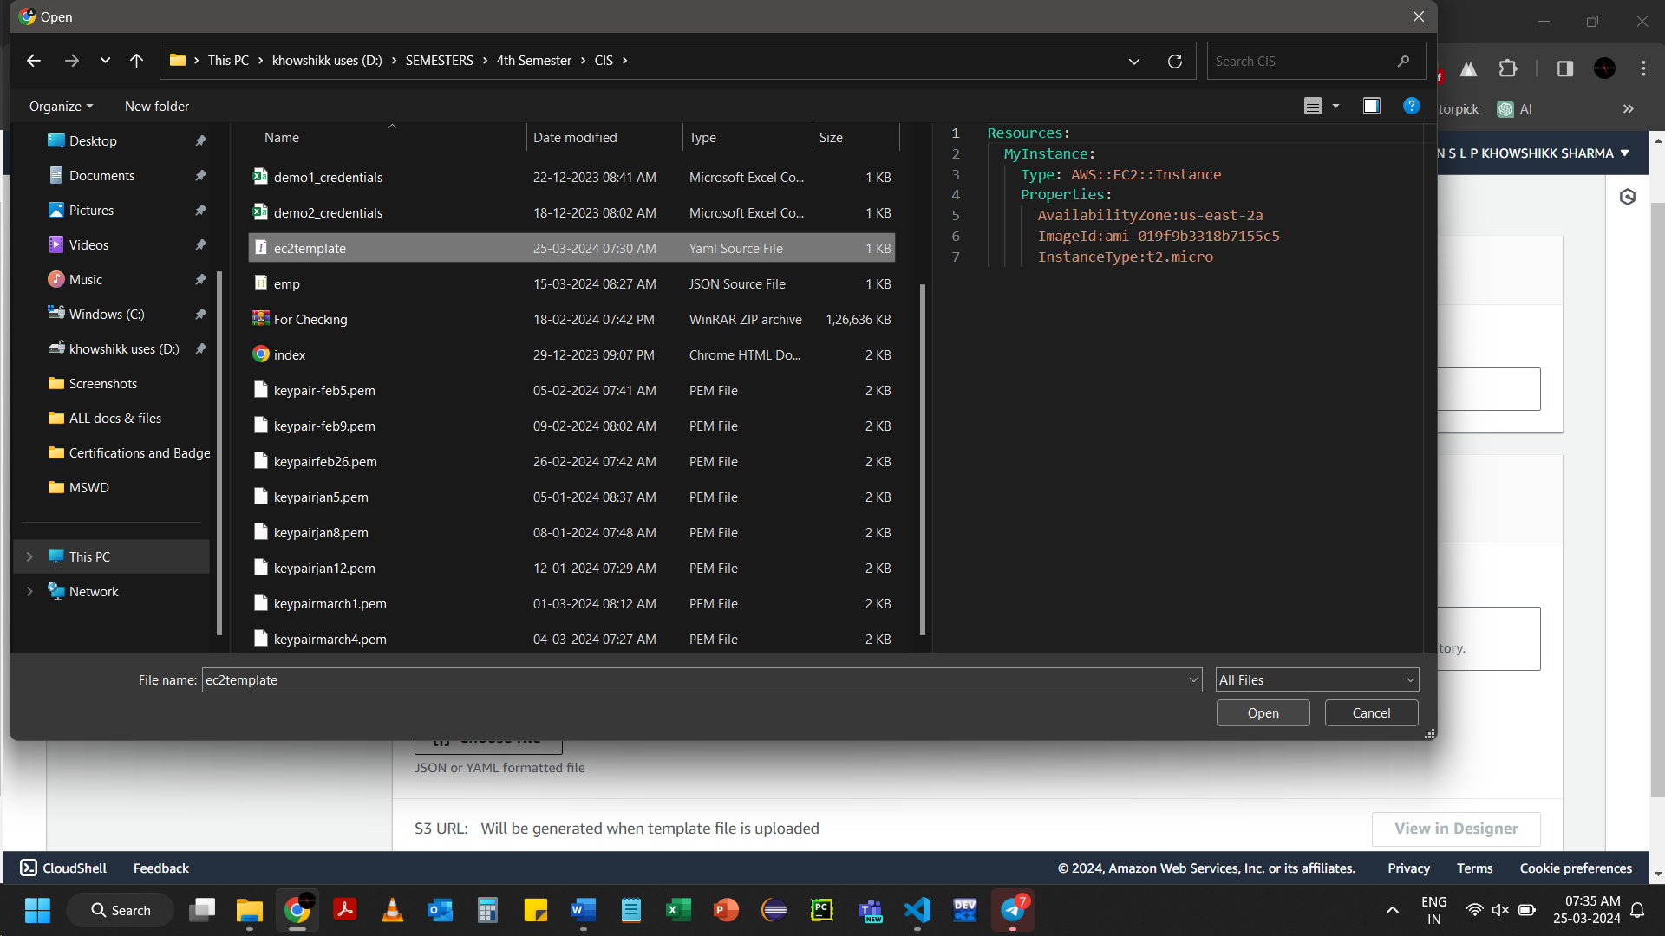Upload the template in Create stack

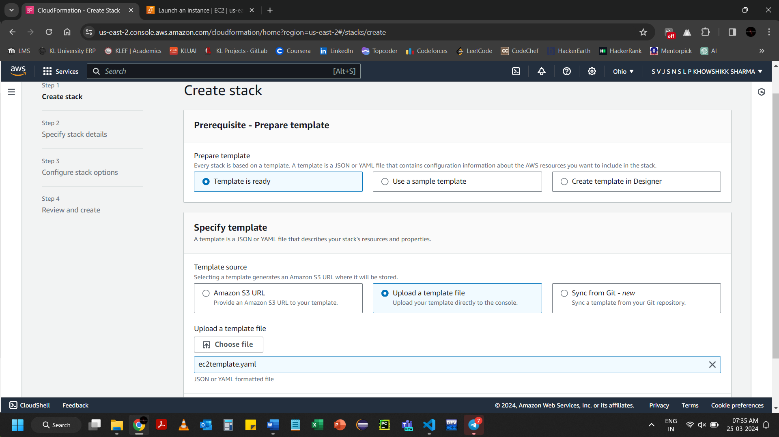Click on Next

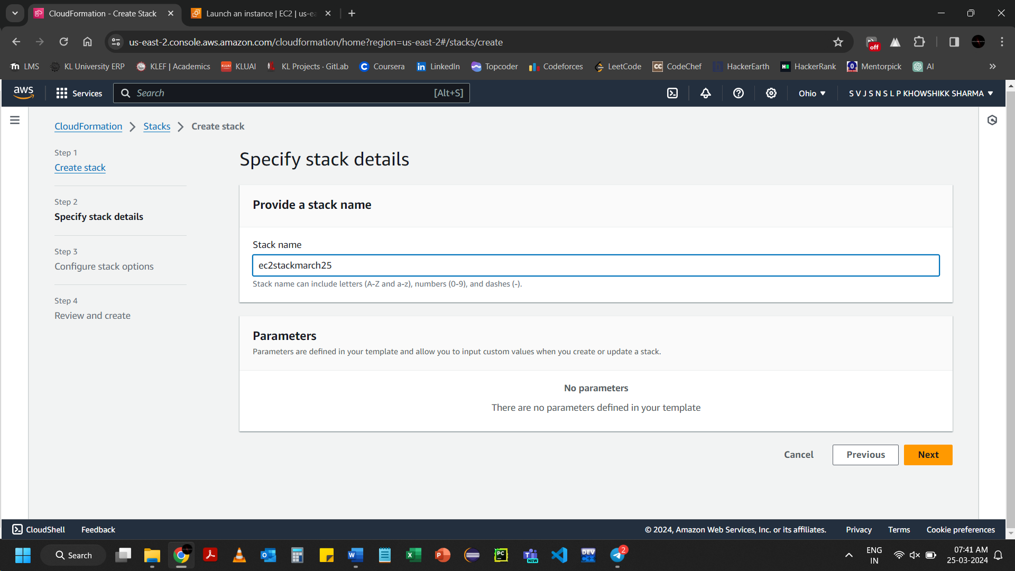

Give stack name and click on Next

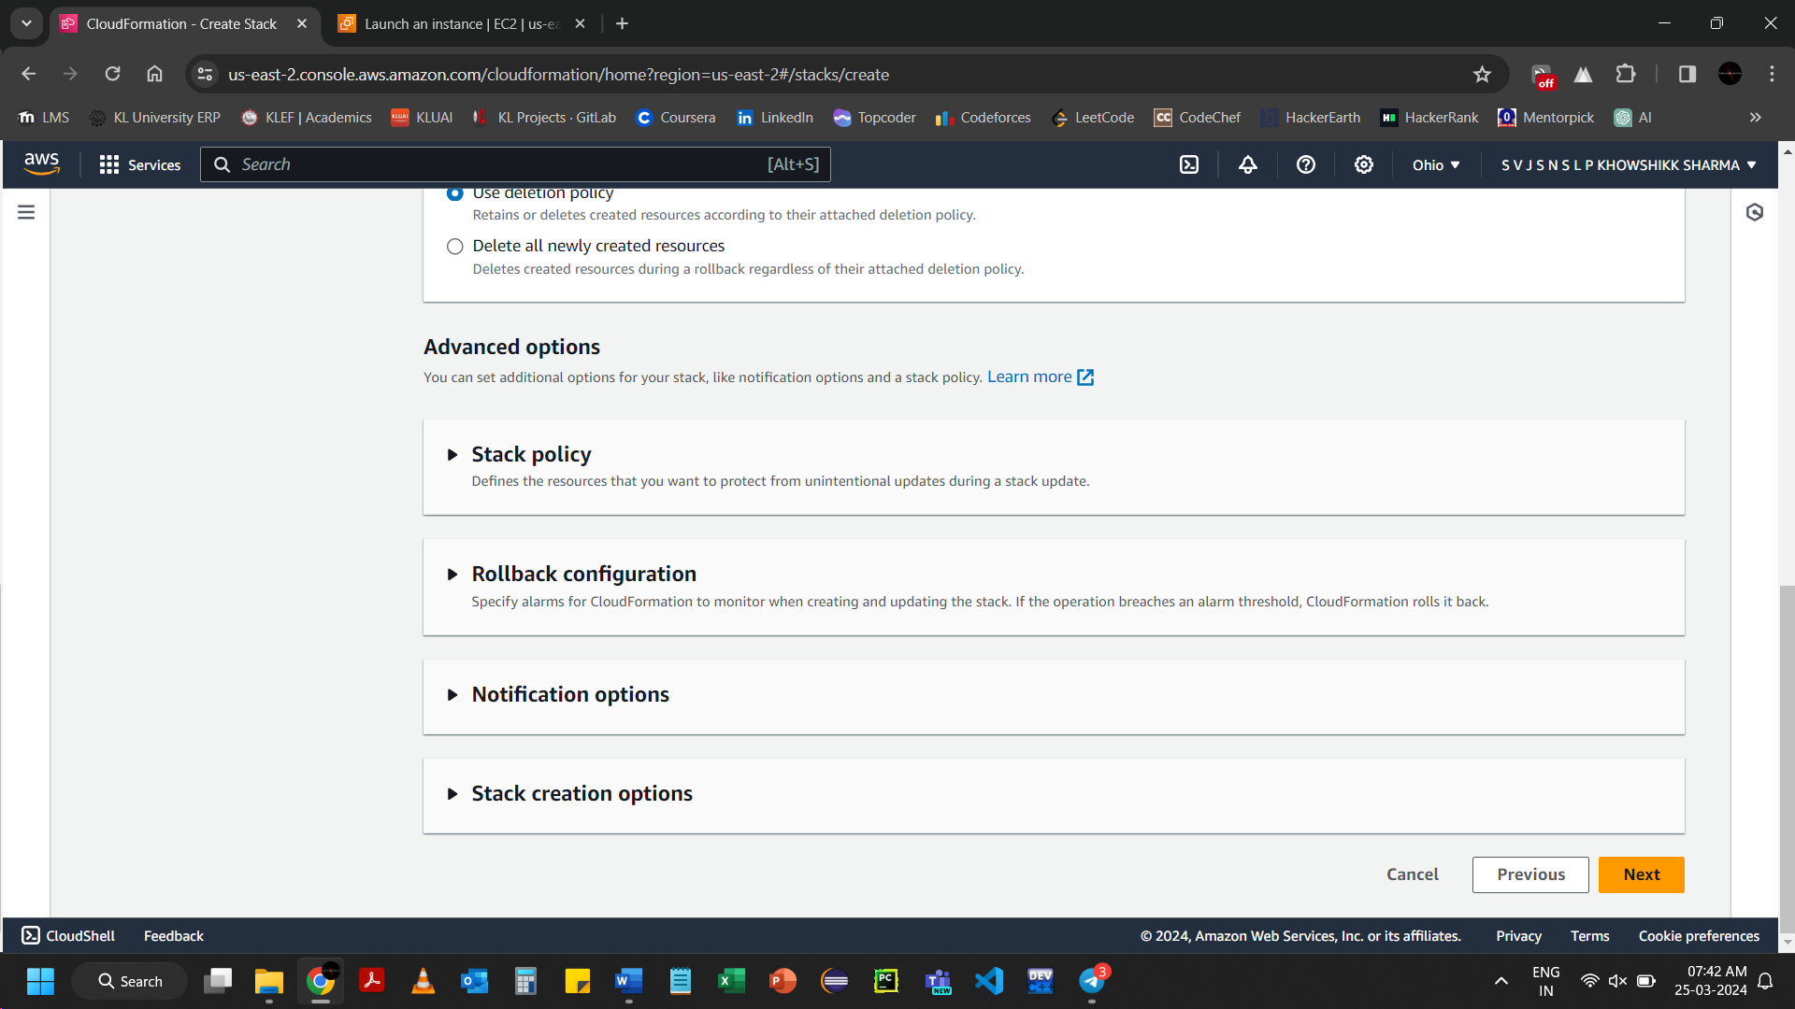Click on Next

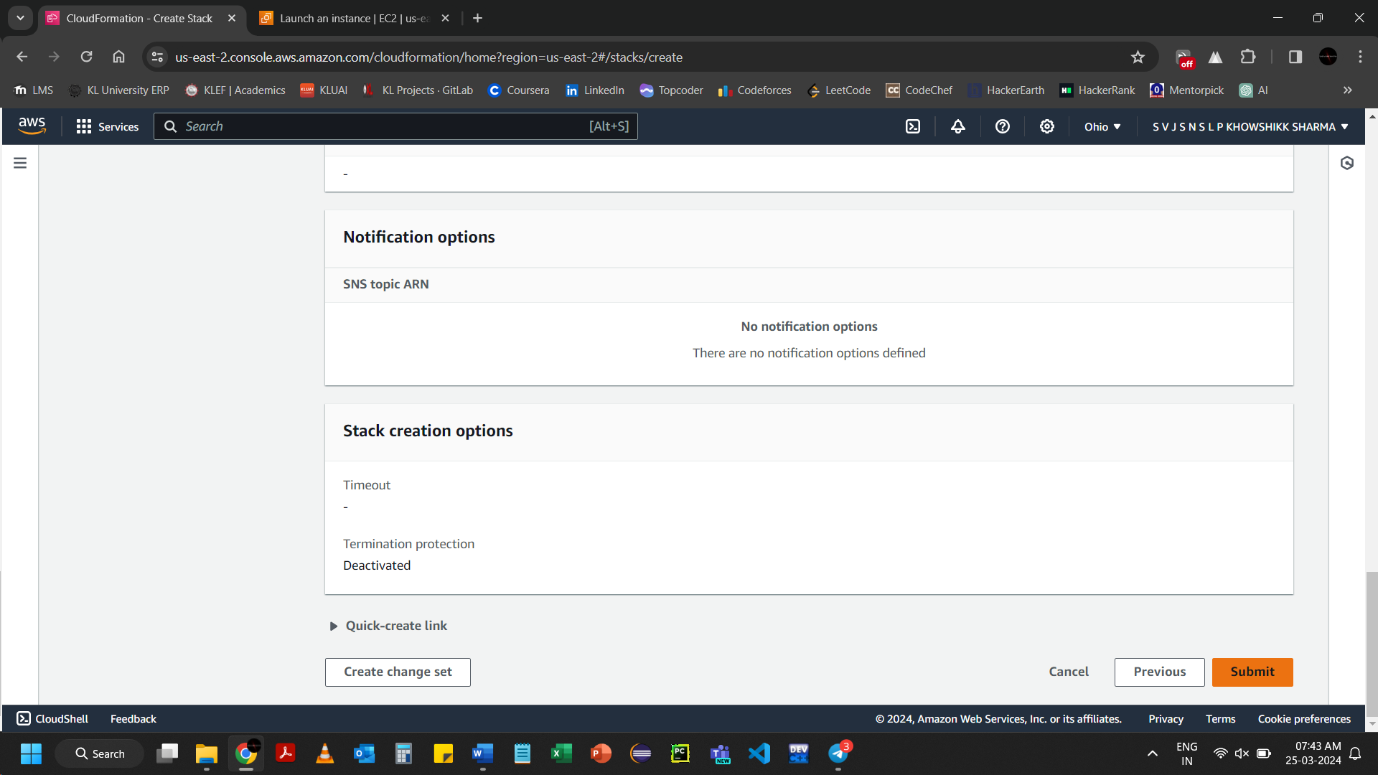Click on Submit

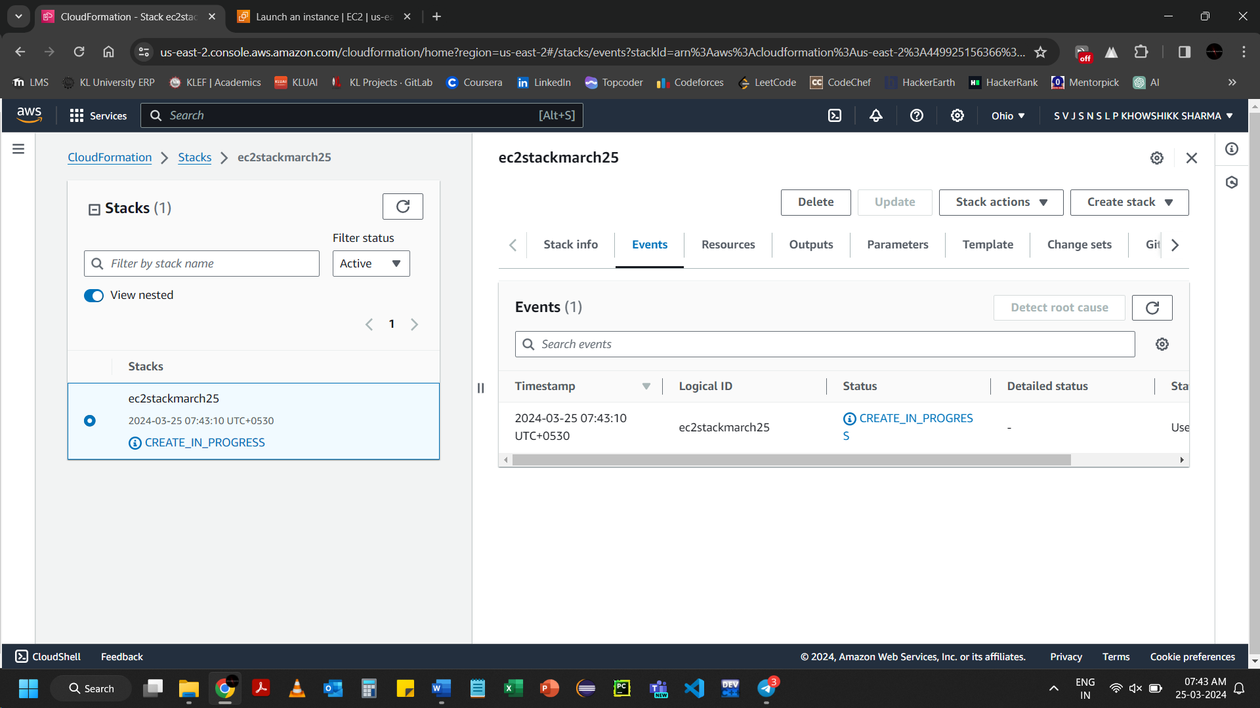

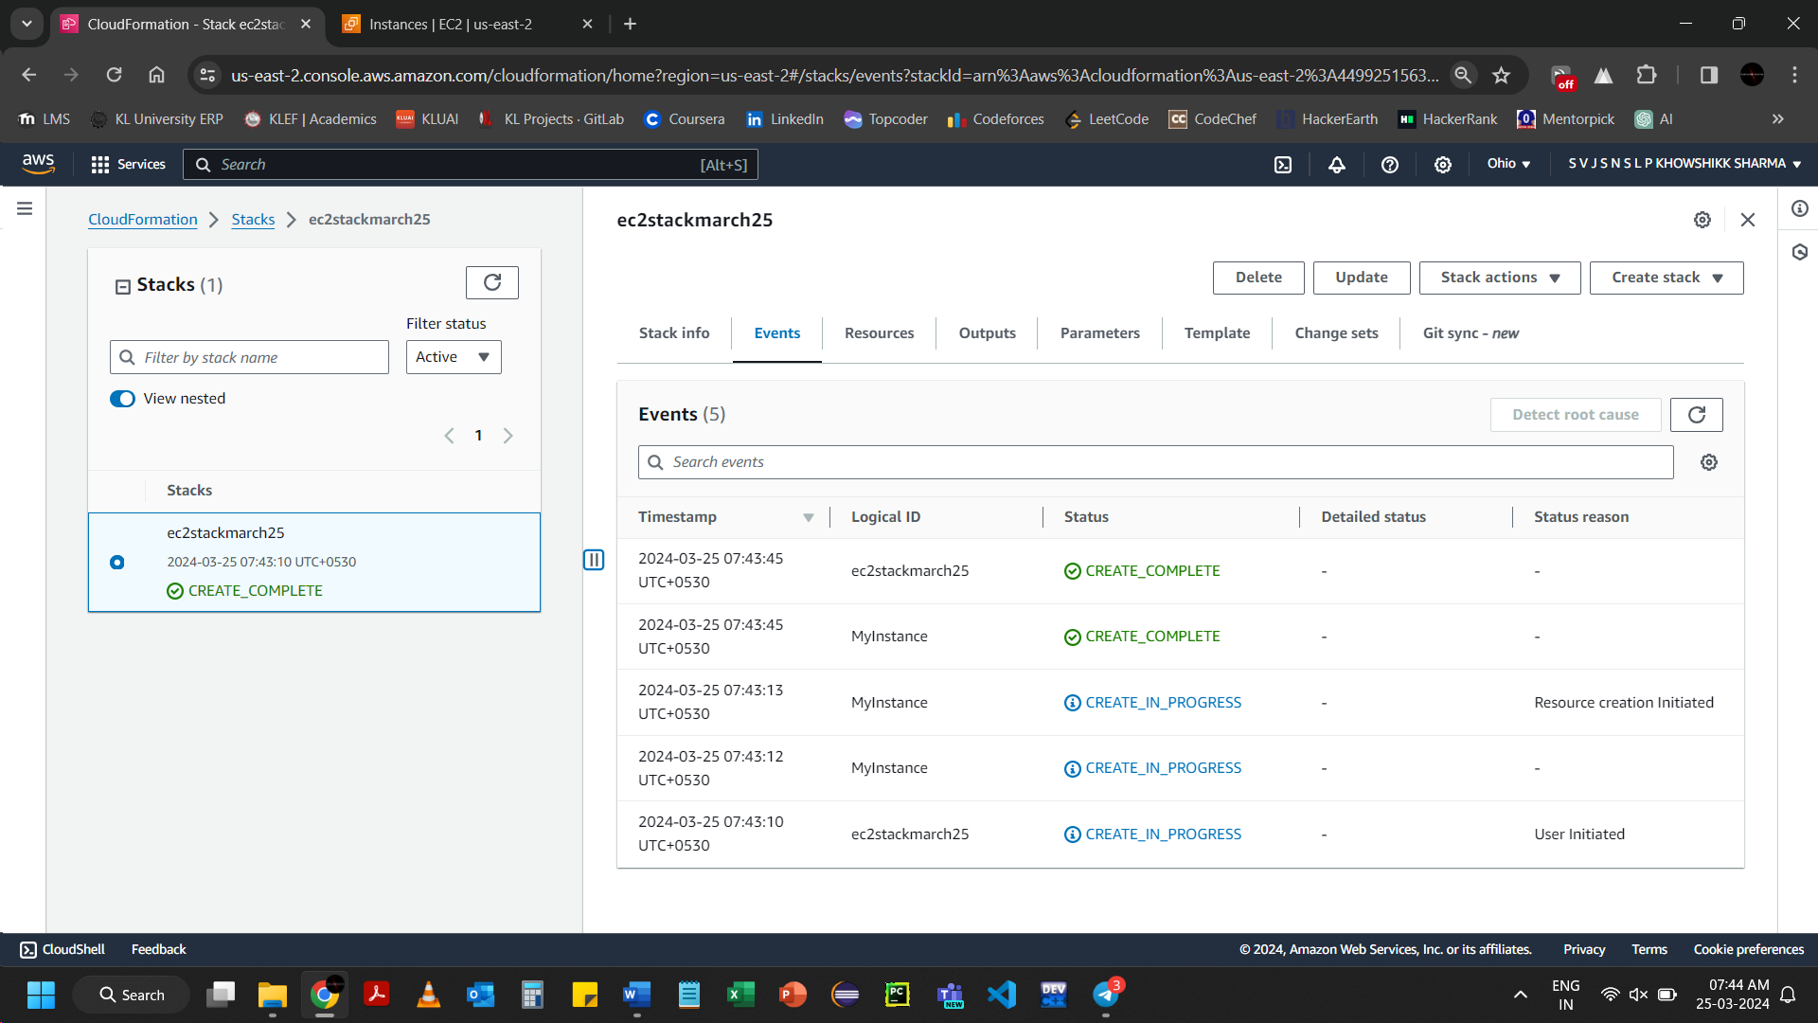

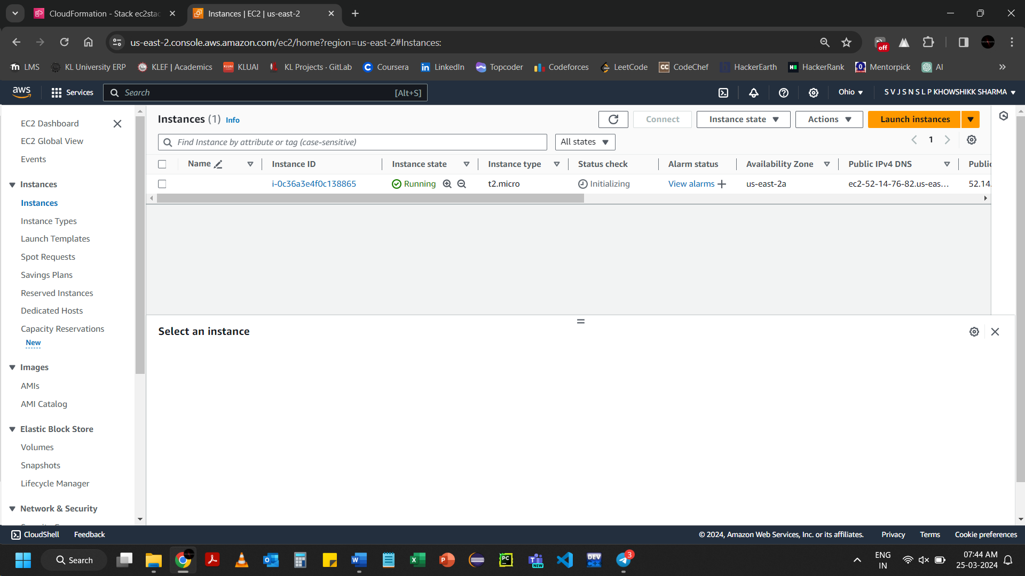

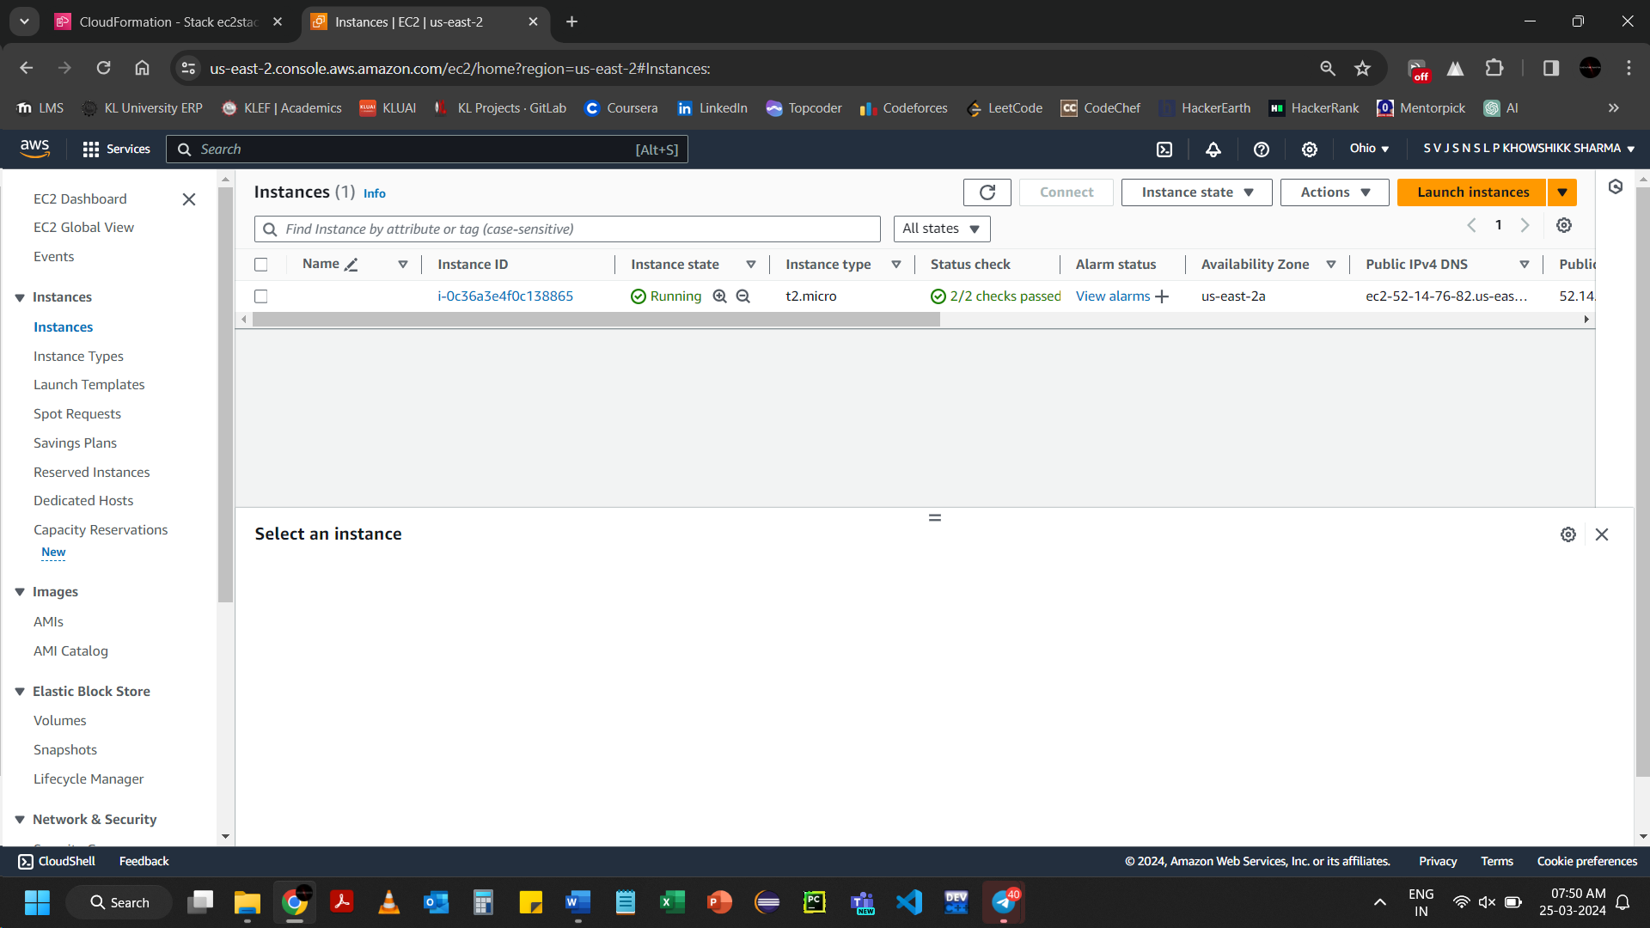

Deleting the Lab

Select the required stack and click on delete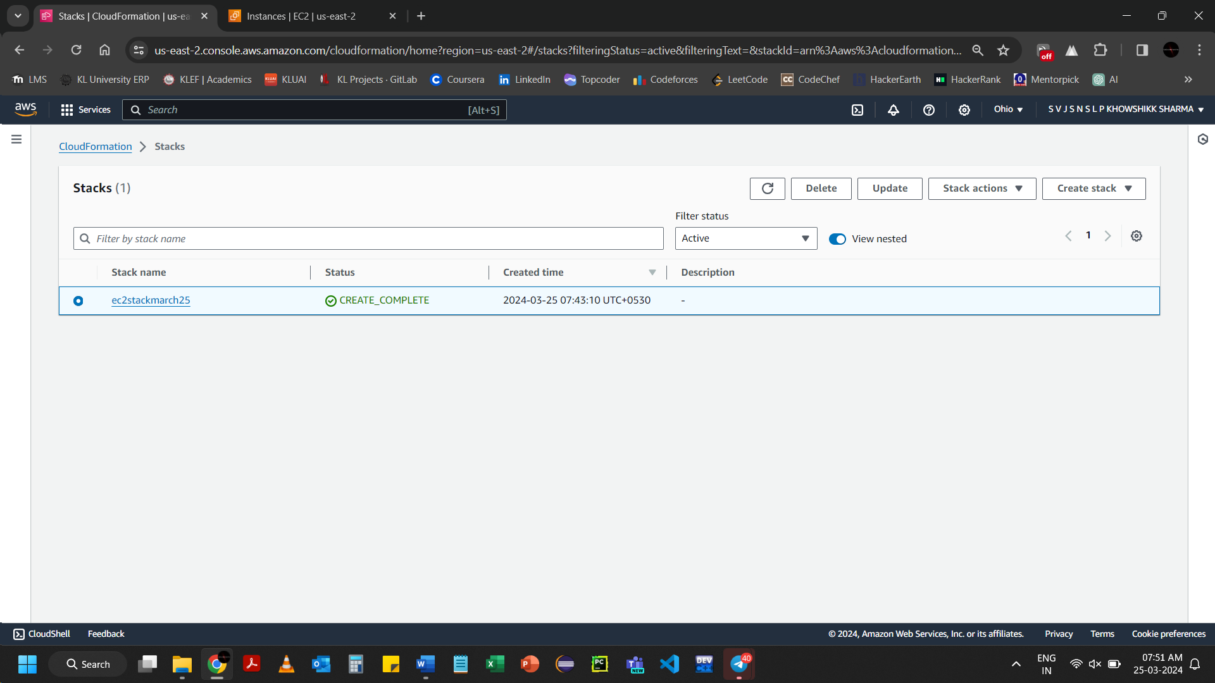

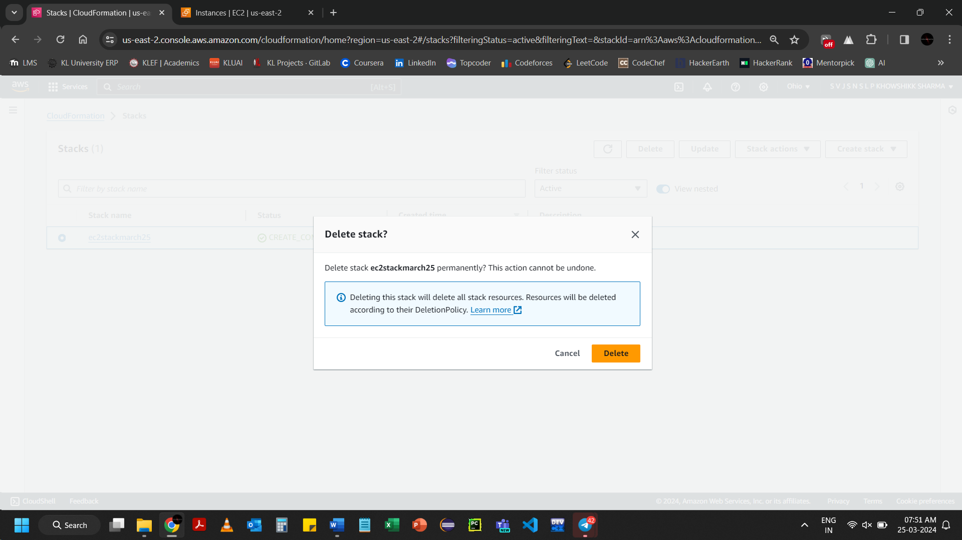Confirm, click on Delete

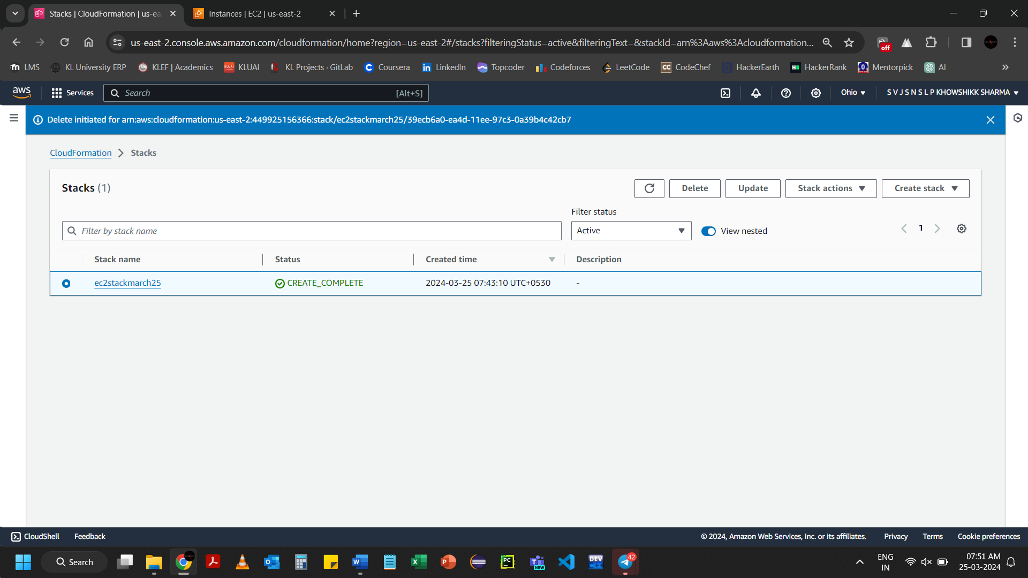

The EC2 Instance automatically terminated when the stack is deleted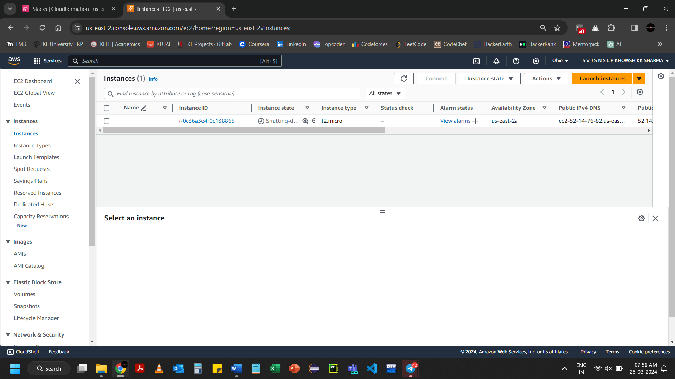

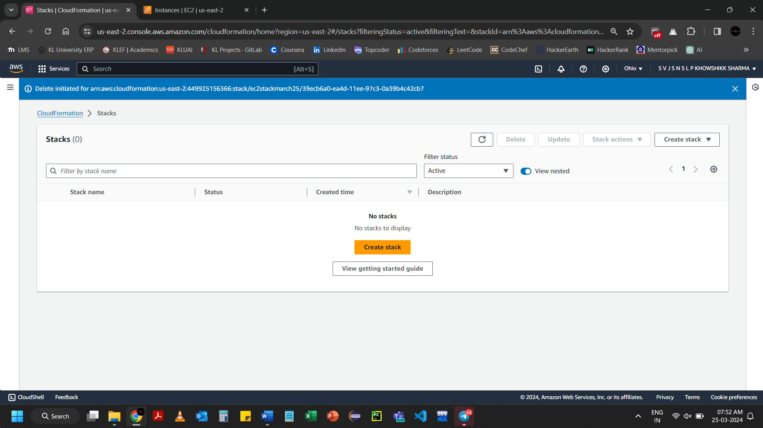

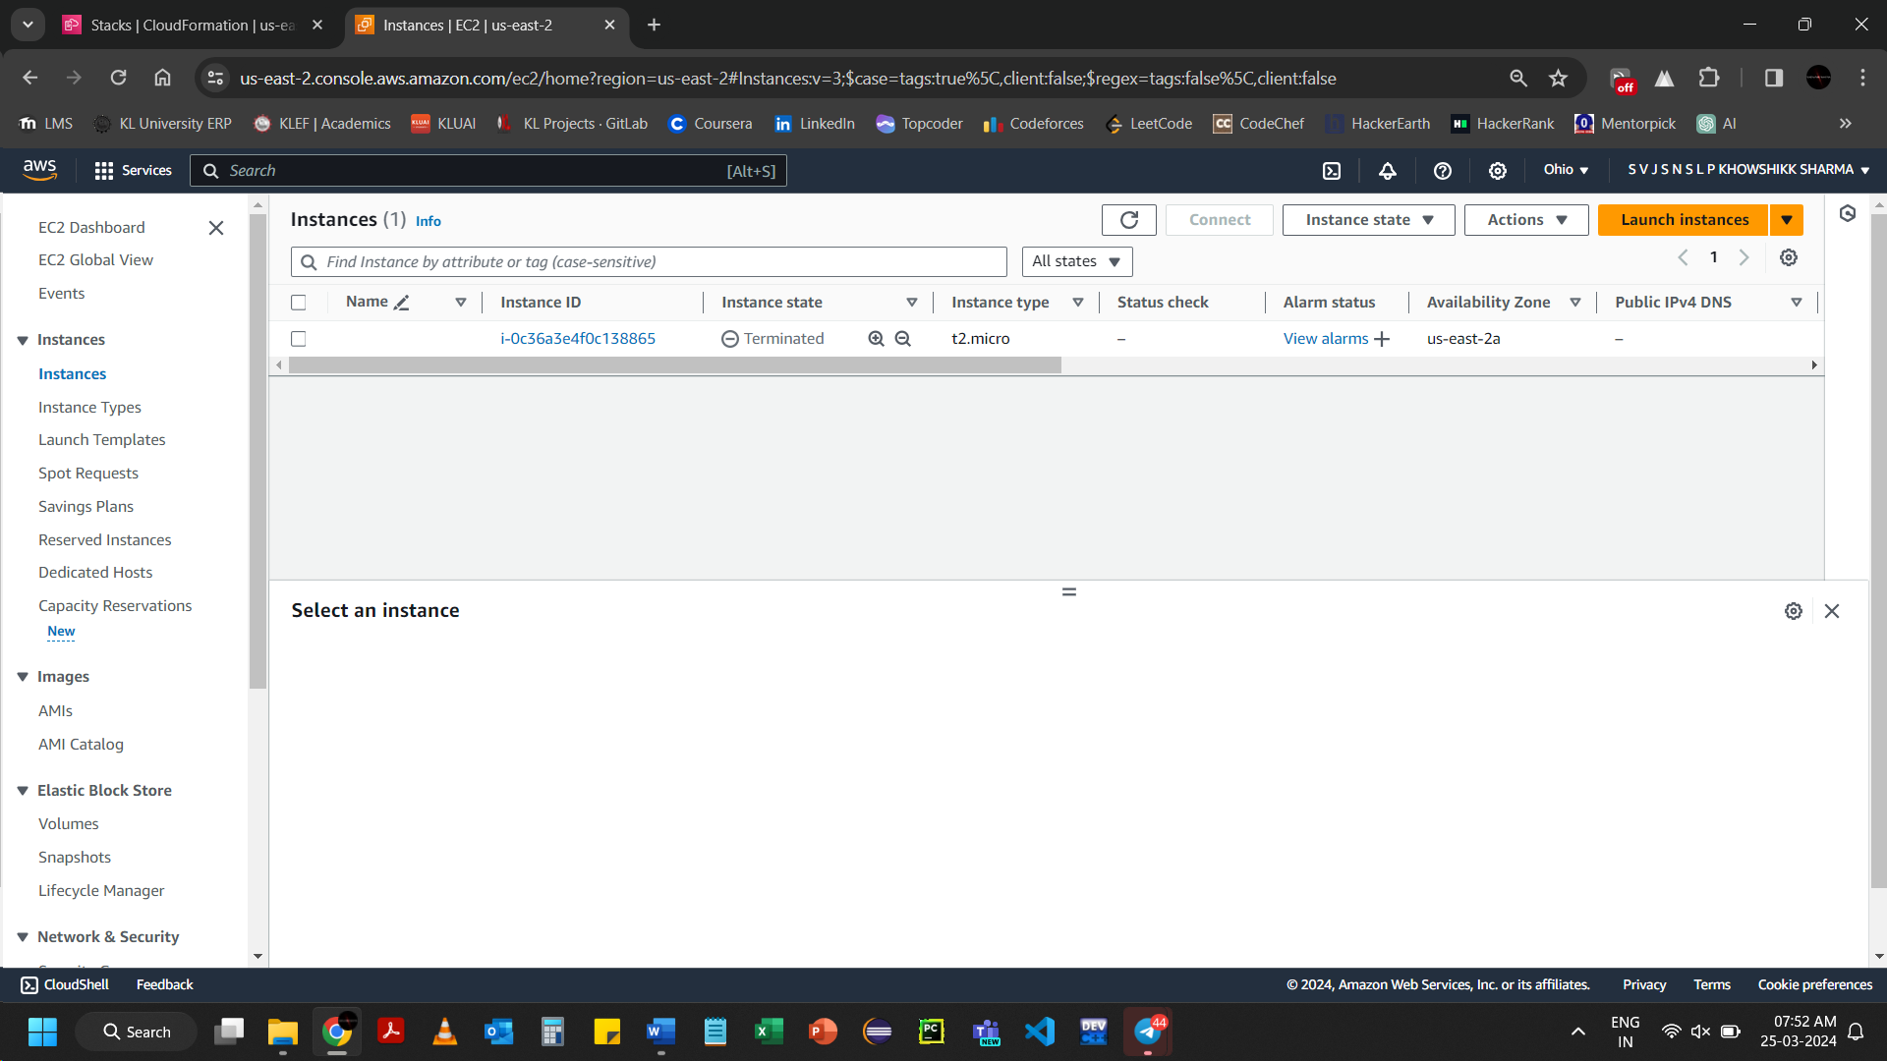

As stack created S3 bucket to store the data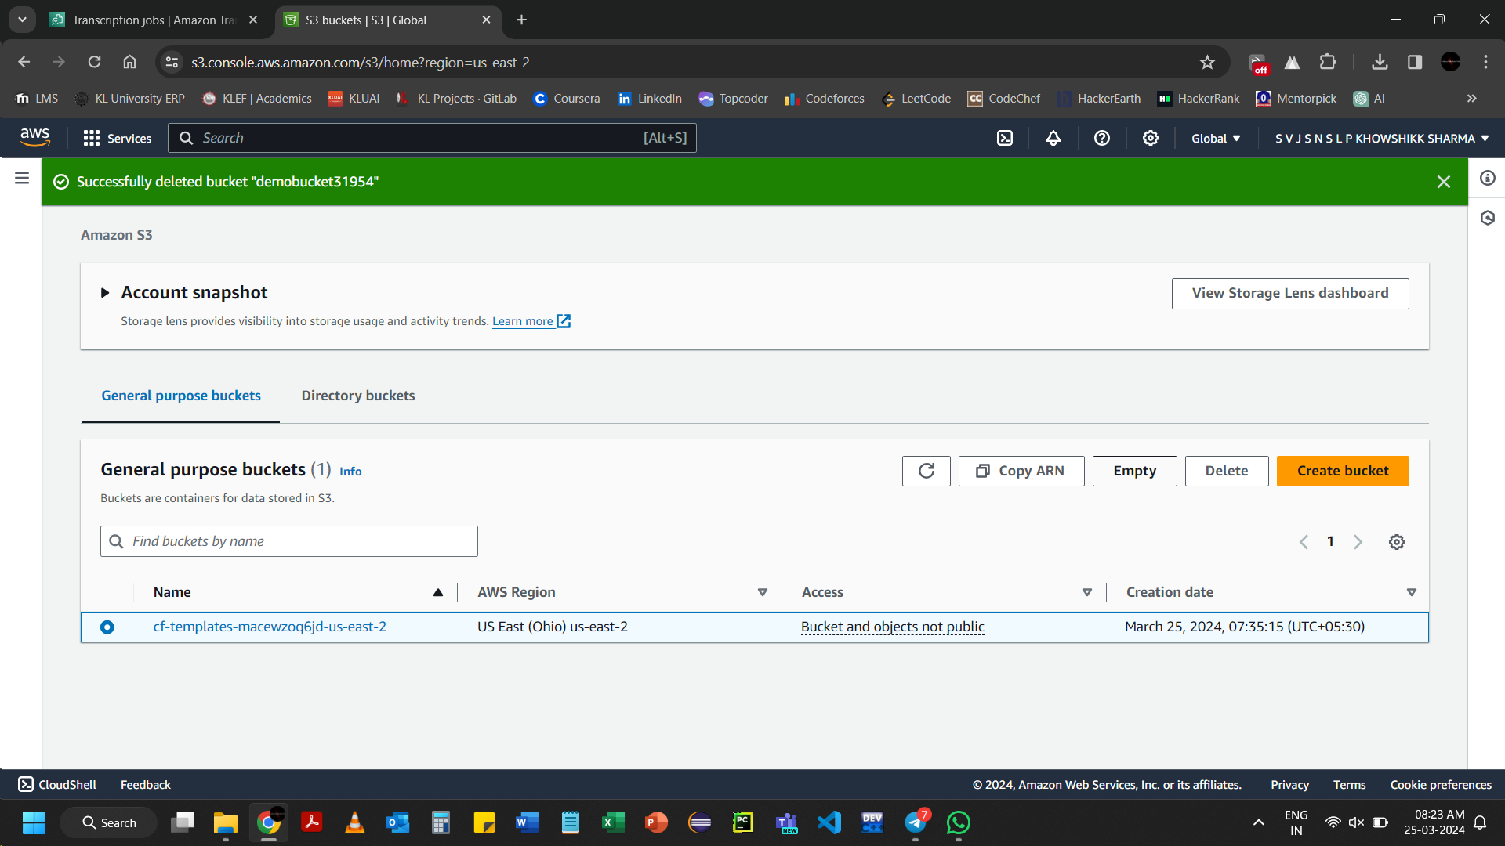To delete, empty the S3 bucket earlier before deleting

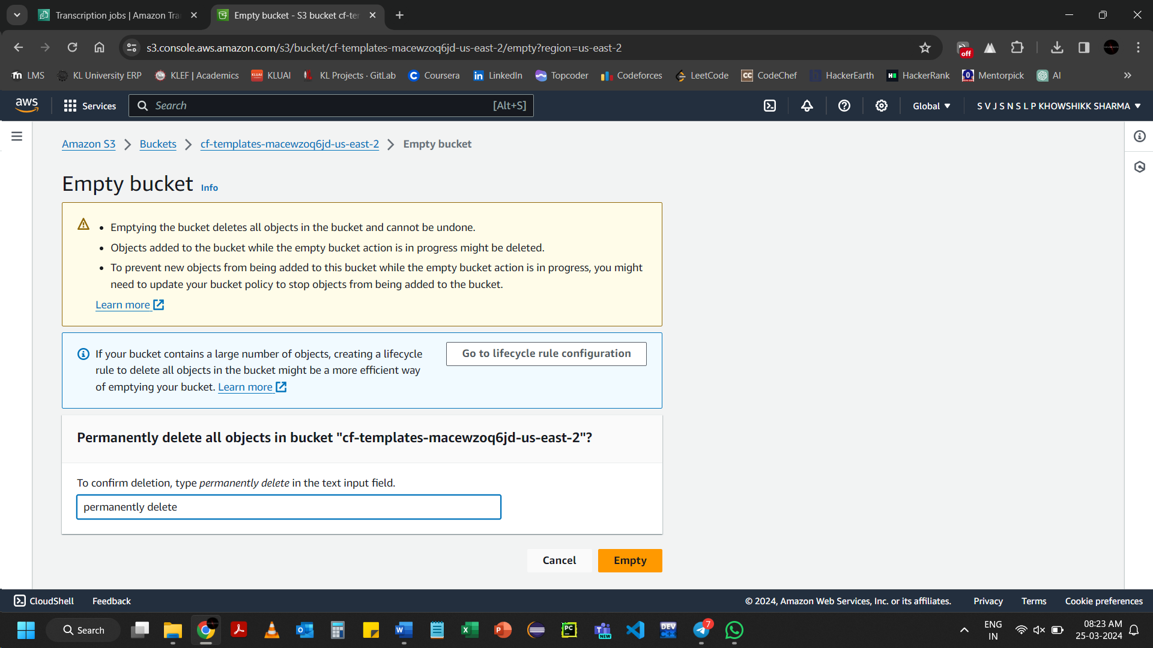Click on Empty

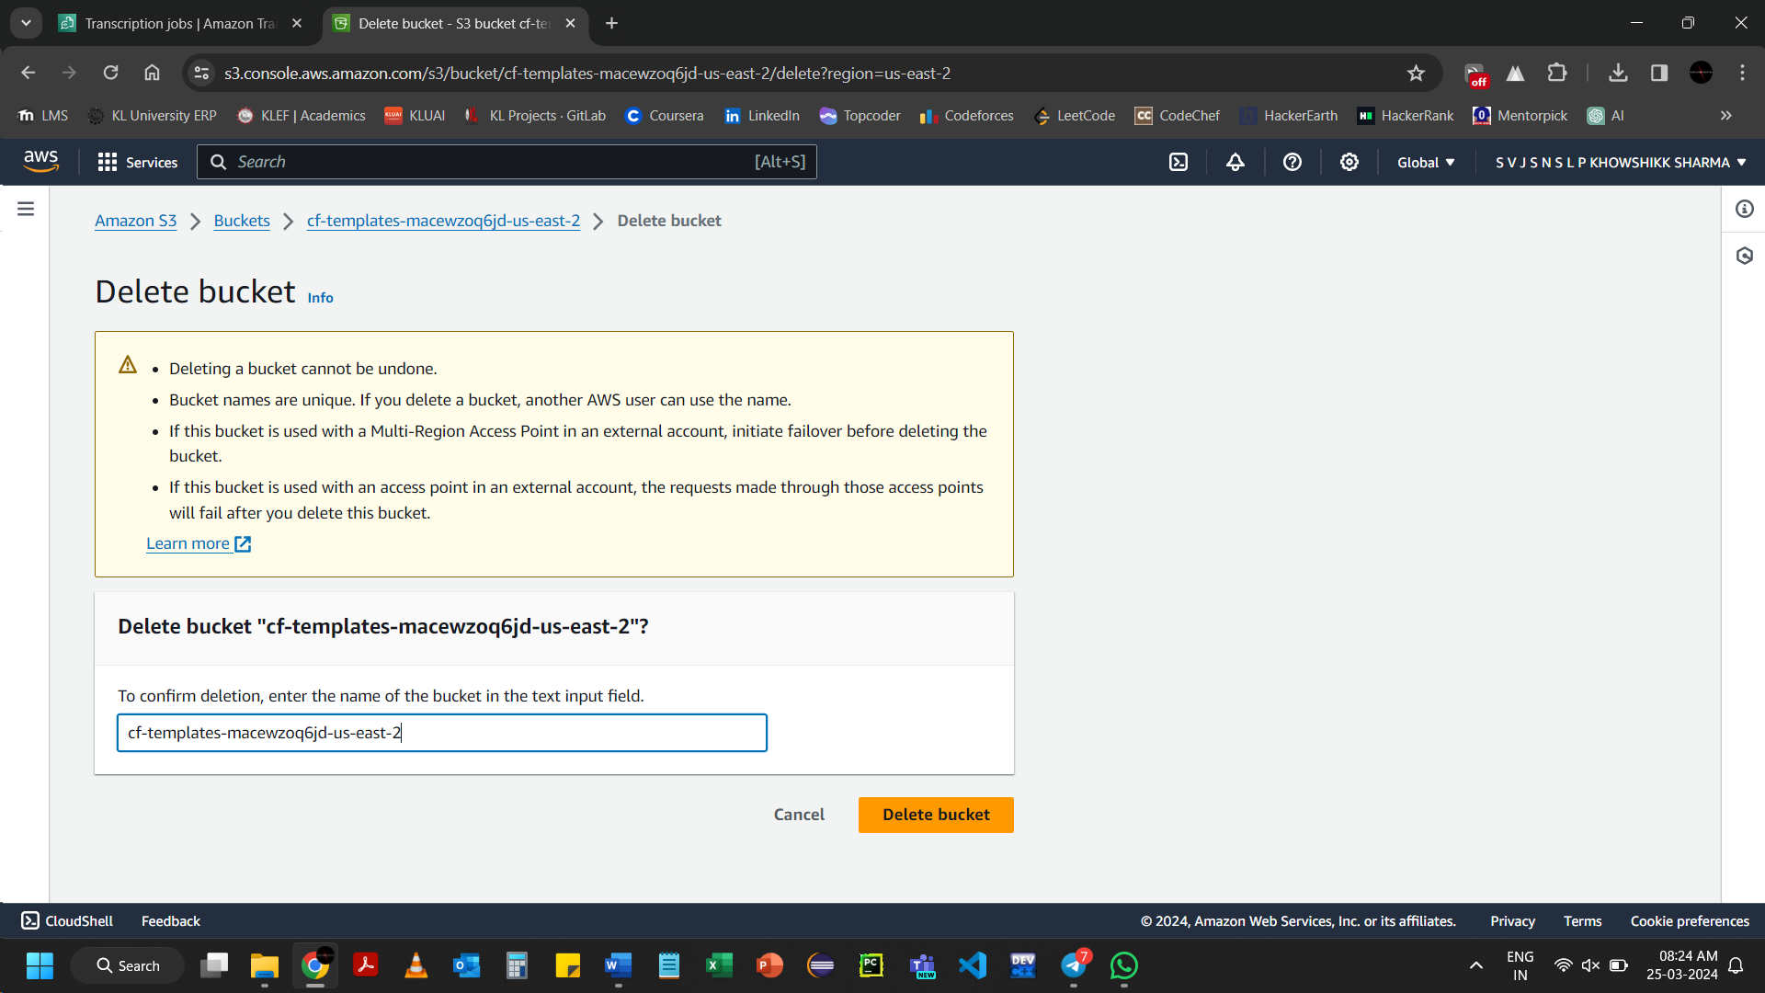Click on Delete bucket

